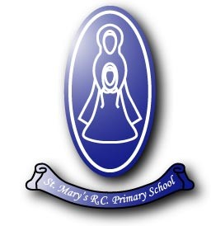

Post: Mid-Day Supervisor

Contract: Permanent - Term Time Only

Hours: 7 hours 30 minutes
Monday to Friday 11.30a.m. to 1.00p.m.

Grade: Grade 3 – Scp 2

Salary: Actual £3,912.81 (based on £22,366 pro-rata)

Required: As soon as possible

Application Deadline: noon Friday 15th March 2024

Interviews: W/c 18th March 2024

We are seeking to appoint a dedicated member of staff who would like to join a caring, dynamic and forward-thinking school.

Hours of work are 7 hours 30 minutes, 11.30a.m. to 1.00p.m., Monday to Friday, term-time only, worked in accordance with service requirements.

Employees of St Mary’s RC Primary School have a responsibility for, and must be committed to, safeguarding and promoting the welfare of children and young people and for ensuring that they are protected from harm.

Appointment is subject to a satisfactory enhanced disclosure from the Disclosure and Barring Service.

In line with safer recruitment, please ensure that your application covers your full employment history and there is a reason noted for any gaps in employment.

For an informal chat regarding the role please contact Mrs Janet Murray on 0161 723 4210 at St Mary’s RC Primary School, Belgrave Street, Radcliffe, M26 4DG

Completed applications can be sent in the post to the above address or e-mail to jmurray@stmarys-radcliffe.org.uk by noon Friday 15th March 2024

Interviews w/c 18th March 2024

For further information, please click on the links below.

Job Description - Job Description.doc

Person Specification Person Specification.doc

Application Form Application Form.docx

